
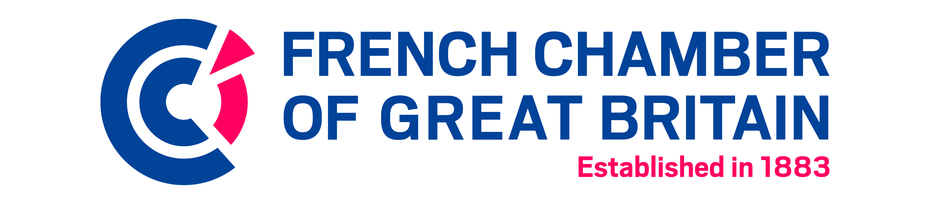
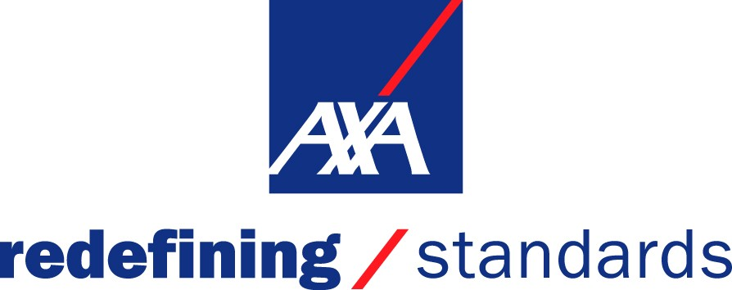

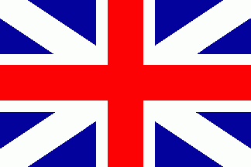

application form
FRANCO-BRITISH INTERCULTURAL TROPHY 2017
When the French and British do business together, what is natural and obvious in one country may be exotic and strange in the other.
The Intercultural Trophy, sponsored by AXA, is aimed at recognising a culturally-intelligent company, organisation or project that has successfully helped to bridge the gap between our two cultures.

The Franco-British Intercultural Trophy, sponsored by AXA, has been awarded by the French Chamber of Great Britain since 1997. The Trophy – designed by Cartier – will be awarded during the third edition of our Cross-Cultural Quiz Evening on 23 February at PwC’s offices.
Past winners include: Boulle International (2016), ESCP Europe (2015), Emmaus (2013), French Radio London (2012), Mazars (2011), Bouygues (2010), Cinémoi (2009), Eurostar (2008), Saint-Gobain (2007), EDF Energy (2006).

Evaluation Criteria
Apply for the Intercultural Trophy if you have recently:
- Led a project that fused the French and British cultures together
- Bridged cross-cultural differences within your business/organisation
- Facilitated the integration of French/ British people either in France or in the UK

SECTION 1: General Information

You are: A French company A British company

SECTION 2: About your company (size, turnover, activities, key facts, etc)

SECTION 3: Your submission details: explain why your company deserves this award (250 words max)

Please complete and return this application form BEFORE 6 February 2017 to
Anne-Claire Lo Bianco, Events Manager
INTERCULTURAL TROPHY 2017
E-mail: alobianco@ccfgb.co.uk / Fax: +44 20 7092 6601

